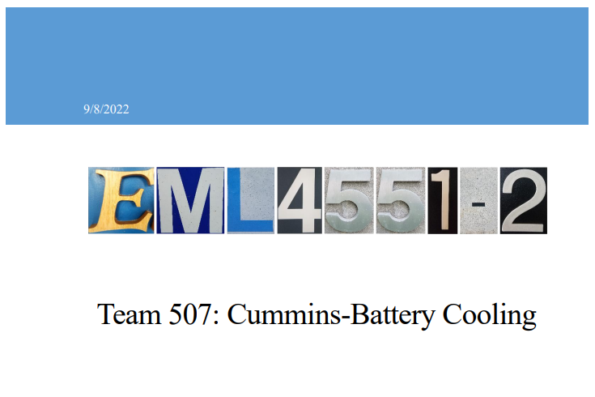

Chapter One: EML 4551C

1.4 Target Summary
Functions and Targets/Metrics
From our functional decomposition we determined ten functions that our product must do to be functional. From each of these functions we determined how we plan to validate each of them as well as specific values that our design will need to meet. The major systems that we determined for our design are Transfer Heat, Safety, and Efficiency. From these three systems we determined each of our functions. The seven functions that we determined for our design were cools battery, heats battery, avoid puncture, withstand thermal cycling, minimize energy loss from pressure losses, minimize weight, and accommodate pouch swelling. Targets were introduced as a means to verify a specific number that each of our functions must meet to achieve the goals of our project. Each function has a specific target and metric that it will be measured against to verify the success of the function. Table 1 shows each of the functions that we came up with along with the metric that will be used to validate, the target value that we will use to design around, and the units of the target.
Table 1: Targets and Metrics for each Function.
Function | Target Description | Metric Description
Cool Battery | <40 [°C] | Temperature
Heat Battery | >20 [°C] | Temperature
Avoid puncture | 20 [N] | Force
Withstand thermal cycling | 2000 Cycles | Durability
Minimize weight | 1.5 [kg] | Weight
Minimize energy loss due to pressure losses | <1 [kpa] | Pressure
Accommodates pouch Swelling | 10% of cell volume [m^3] | Size

Targets/Metrics Beyond Function
The targets that we determined that go beyond our functions are shown in Table 2. These targets include keeping the cost of the design under $150, using materials that are not going to rust or fluids that will freeze, and the design must fit into a module with dimensions of 340 mm length, 230 mm width, and 50 mm height.

Table 2: Targets that go Beyond Functions
Customer Need | Target | Metric
Minimize total cost of ownership | $100 | Cost
Method is resistant to changing weather conditions | Rust and Freeze Resistant | Durability
Method adds minimal volume to the module | 340x230x50 [mm] | Size

Critical Targets and Metrics
The critical targets for this project are to cool the battery, avoid puncture to the battery cell, minimize energy loss from pressure losses, and minimizing weight. It is crucial for the developed method to cool the battery to the desired temperature. If the battery reaches too high of a temperature, then there is a heightened risk of critical failure to the battery. Thermal runaway is another risk for battery packs that must be avoided if the temperature of the cell gets too hot. Furthermore, if the battery cell for the device is punctured then there is a risk of creating a lithium fire. Beyond failure of the battery, this would cause a significant safety risk, so the developed method should not induce the risk of puncture to the battery cells. Another critical target and metric for our project is minimizing energy loss from pressure losses. If a fluid is pumped through the module a pressure loss will be generated from the friction losses within the system. Higher pressure losses require a larger pump which will use more energy from the battery pack to power it. Minimizing pressure losses is crucial for our project because it will allow our method to be more efficient. The last critical target and metric for our project is minimizing weight. A higher battery module’s weight means that the vehicle will have to move more mass. This makes the vehicle less efficient and makes the total cost of ownership of the vehicle increase.
Derivation of Targets and Metrics
To derive the cooling of the battery function we researched temperature ranges that lithium-ion pouch cells can withstand during operation. We found that these batteries need to stay under 40 °C and if they go over this temperature the battery will begin to degrade and eventually catch on fire if it continues to get hotter. To derive the target for avoiding puncture of the battery we researched how much force is required to puncture a pouch cell. We found that a force of 20N (5 lbf) is enough to puncture a pouch cell. For the pressure loss we researched how much current pressure loss current cooling plate design have. The value varied, but the most optimized pressure drop we found was around 1[kpa]. Our pressure drop target is to have a pressure drop through our system that is less than current cooling plates. Lastly for the weight of our design we researched the current industry weight of battery packs, modules, and cells. We found that on average the cells inside of a module make up approximately 80% of the module weight and the module shell and cooling systems make up about 20%. From there we calculated that for a four-cell module design the entire weight would be approximately 8kg. Taking 20% of this value gave us a design weight of 1.5[kg].
Method of Validation and Measurement
To test the cooling of the battery with our design we are going to use heating pads. Since we can’t use real lithium-ion pouch cells due to safety concerns, we are going to use heating pads that produce the same amount of heat flux that the pouch cells would when they are being discharged. From there we will use a temperature sensor to monitor the temperature of the battery module at different locations to see if our design keeps the temperature of the module under the target value. To test the pressure drop within the design we will need to use a pressure sensor at the inlet and the outlet of the coolant passage and determine the difference in the pressure at the two points. This is a key test for our design because the efficiency of the design is important in determining if the design improves upon existing cooling methods. To validate the weight of the design we will use a scale to measure how much it weighs. This measurement will be an empty design with no heating pads inside of it.

